INDIVIDUAL MINI-PROJECT REPORT

PIUS AMARTEY QUAYE VIBE

1928477

* Objective:

Components

* Circuit Diagram & Fritzing Schematic:

Experimental Planning

Circuit Setup

* A Program:

Arduino Code

* Testing:

Test & Results

* Conclusion:

Objective:

For my Arduino mini project, I decided to base my project on IT Security, where I would build something that can help with general security and I will be using Tinker card. After scrolling through Tinker cards available resources, I decided to build a security device that detects motion of an object in its field and alarms user in some way, this can be used as a security system to notify someone when another person enters an area without their knowledge and alert them.

Components:

The following are the components I will be using for this project:

* 1 Arduino Uno (Microcontroller Board)
* 1 Piezo Buzzer (Audio signalling device)
* 1 PIR Sensor (Motion Sensor Device)
* 2 LED bulbs (RED AND GREEN light emitting diodes) (
* 3 Resistors (220 ohms)
* Wires

Experimental Planning:

When Arduino is powered on A green LED remains constantly flashing indicating that there is no movement in the area, If and object enters the PIR sensors field of area then a red LED flashes instead for user to know, also whiles this is actively going on a Piezo Buzzer will make a loud constant noise to alert user as well and lastly a Serial print text will display (“INTRUDER”) alerting user that there is an intruder.

Circuit Setup:

* First, power and ground were connected to the breadboard through a uno Arduino.[1]
* Two LEDS with voltages of 3V / 20 Ma. A red bulb and a resistor are connected to the board with a wire connecting to digital pin 13 same with the green bulb also with a resistor and connected with a wire to digital pin 12.[2]
* A Piezo buzzer, connect the red pin being the positive pin of the piezo with a wire then it is connected to the pin 7 of the breadboard whiles the negative pin connected to a wire to the ground of the breadboard.[3]
* Connect a PIR sensor to the breadboard, the power pin of the sensor connected to a wire to digital pin 4 on the uno Arduino. A wire connected to the power pin of the sensor to the power bus of the breadboard and the ground pin also with a wire to the ground bus of the breadboard.[4]

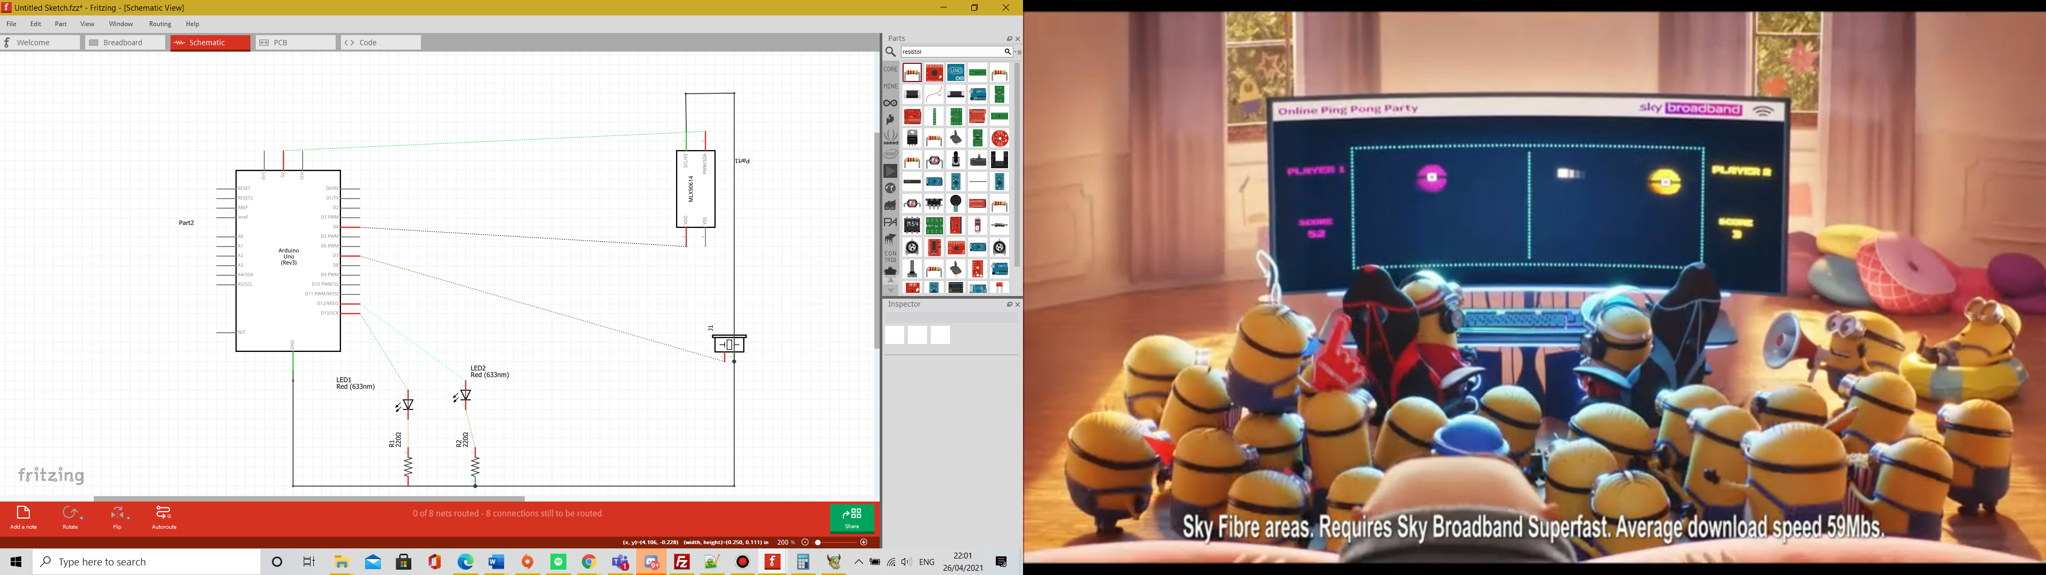

2

4

3

1

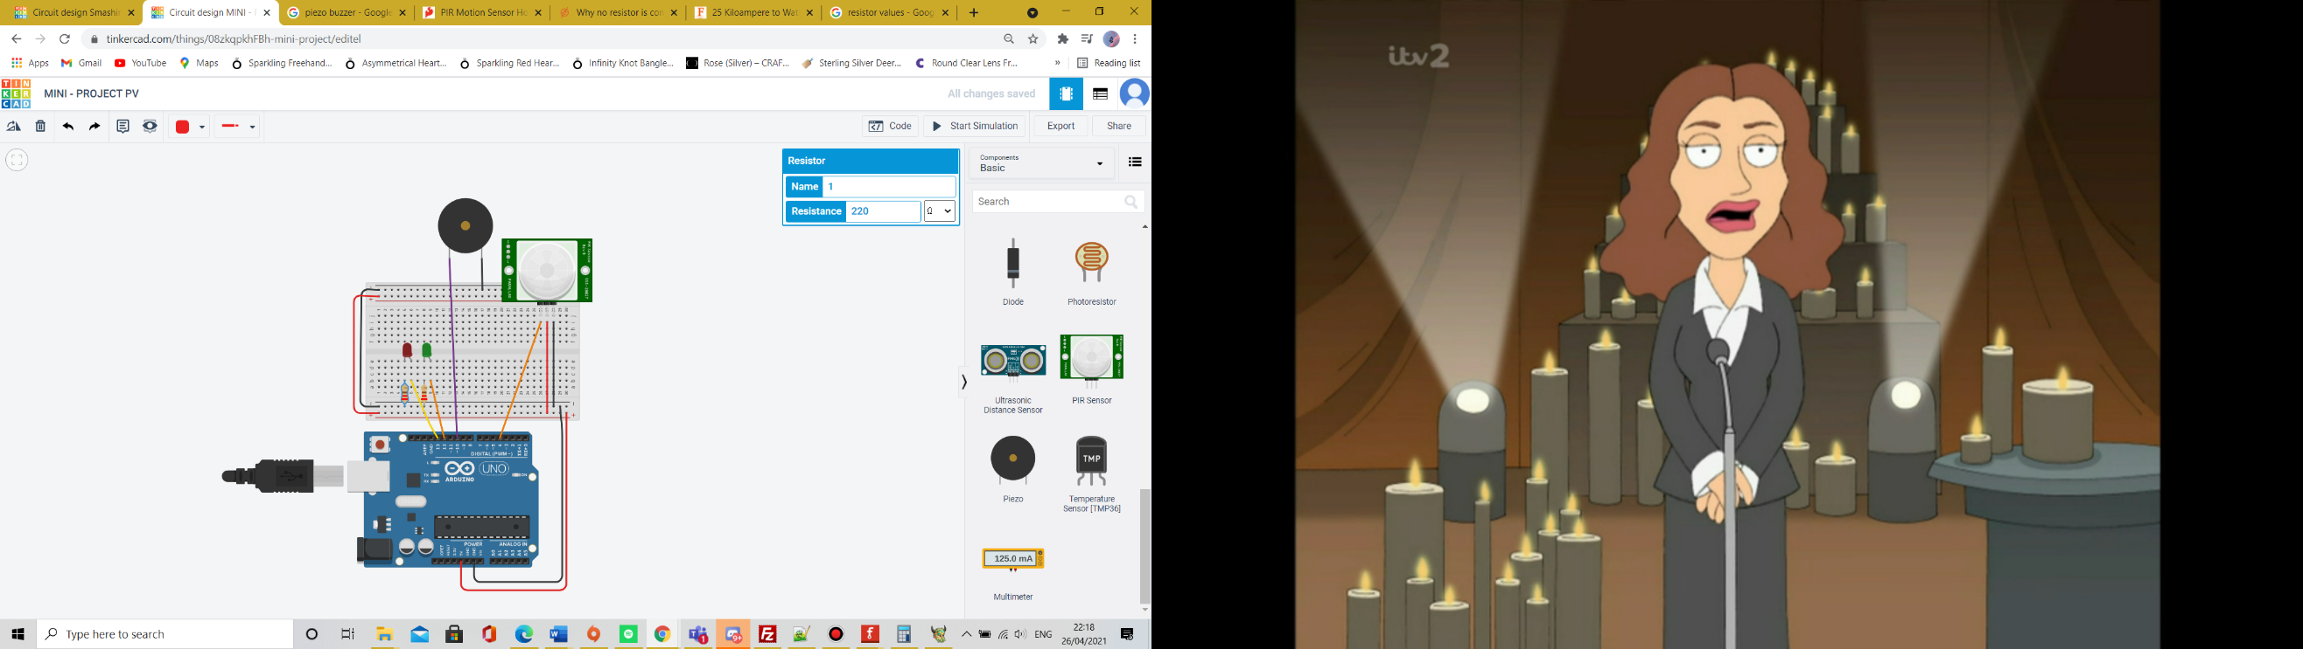

For the LED bulbs I needed to make sure that they needed the right amount of resistance otherwise they will not work in tinker card. So, for this using OHMS Law we know we are using a 5V power source from our Arduino and LED uses 2v and for Tinker card the bulbs can use up to 20mA for an optional performance so the resistor must be at least:

R=(5v-2.0v)/0.02A=150 ohms.

Since to make the simulation more realistic I will be using 220 ohms as these are the most likely ones to buy in real life. In we can see this work

 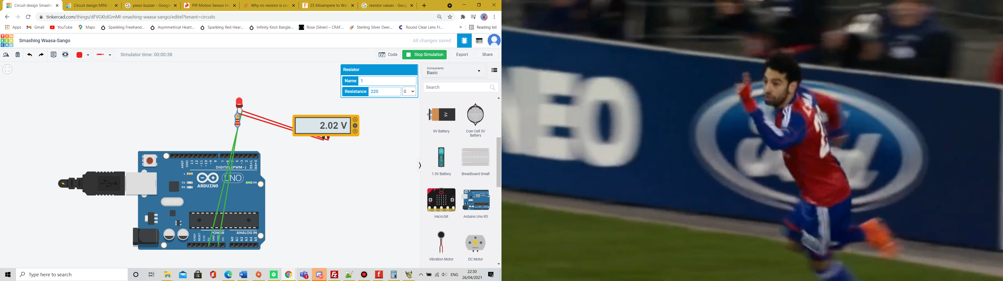

In my calculation I calculated with a 2v drop but in the simulation seems to be a 2.02 which will still work on the left with a lower resistor (140ohms) the bulb will have a shorter life span than the one on the right (220 ohms). We know it is a 20mA as Tinker card tells us.

Arduino Code:

I have written down my using Tinker card displayed below:

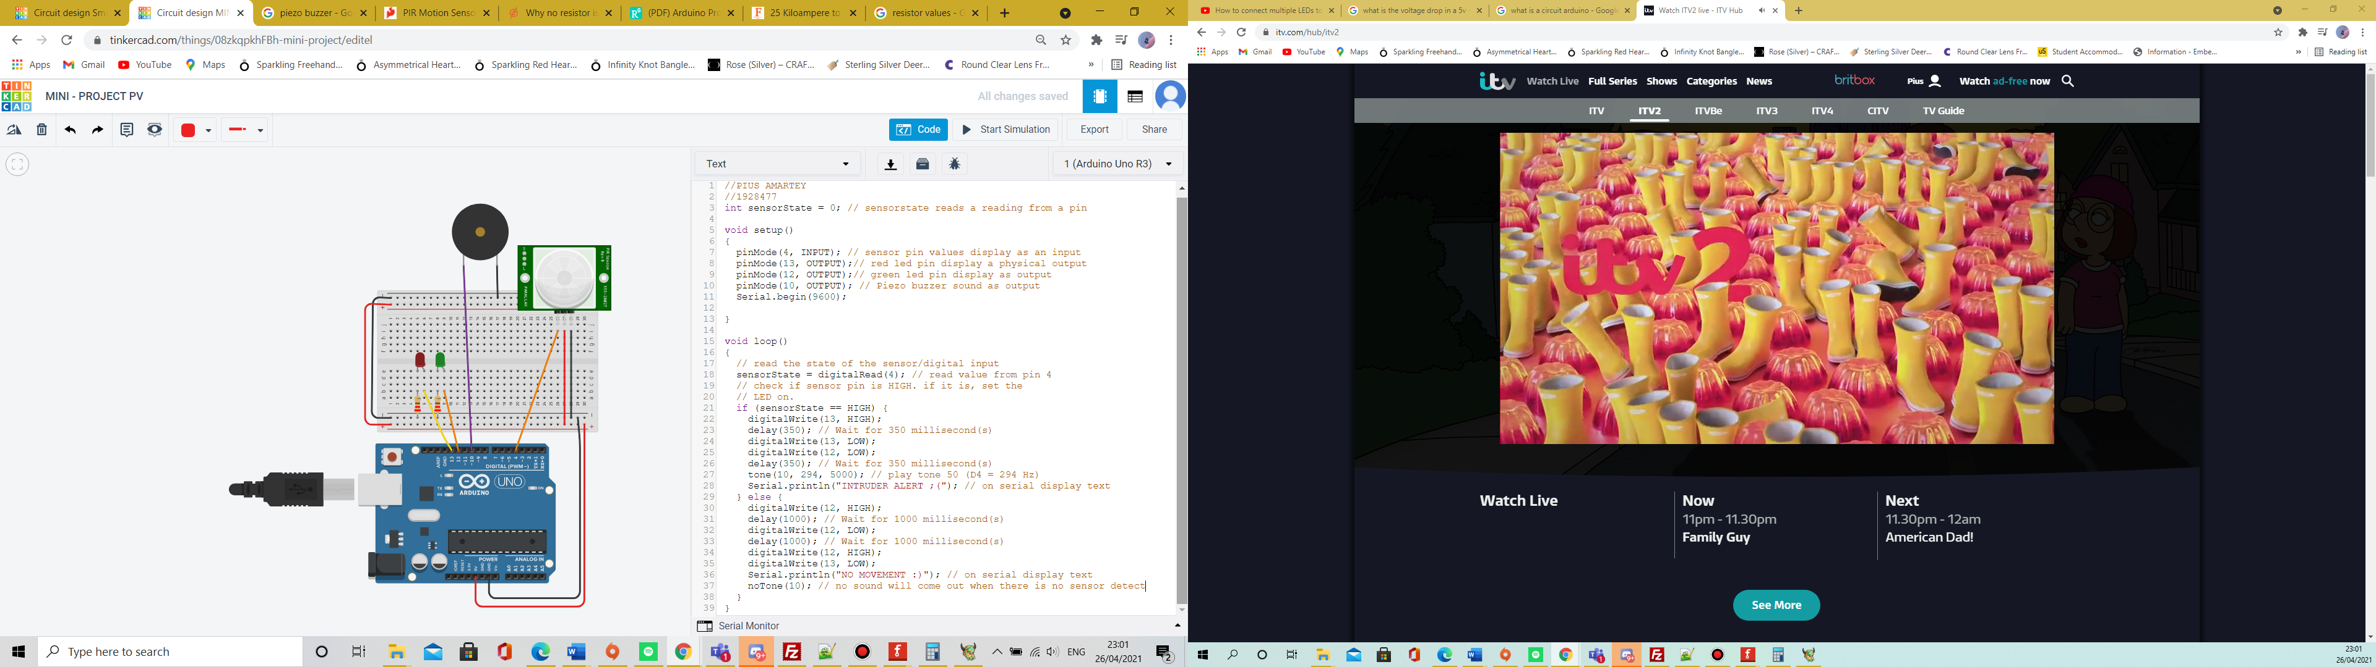

Testing:

I tested different parts of the project to see if they work the way I intended and write down results:

|  |  |
| --- | --- |
| Test | Result |
| Test Code runs with no errors on Tinker card Simulation | Test Code runs fine with no errors |
| A Second delay between Red and Green LED switching. | 4 seconds delays in between Green and Red LED when switched. In my code there is no delay for if each one is on or off but there are second delays in between sensor reading |
| A 2v drop in voltage when LED is lighted with a 220 ohm. | Using a multimeter voltage drop was 2.01V with a multimeter in the full circuit but 2.0V when alone. In simulation I cannot see how this may affect the Led bulb |
| Piezo buzzer stops beeping when object is not in PIR Sensor area | Piezo stops 4 seconds after object is out of the area of the PIR Sensor. In my code there is also no delay in reading but does not switch off immediately when there is no reading but only after 4 seconds. |
| PIR Sensor serial prints “intruder” when PIR sensor has an object in its area | “Intruder” shows repeatedly in serial print after sensor detects object |
| PIR Sensor serial prints “intruder” when PIR sensor has an object in its area | “no movement” shows repeatedly in serial print after sensor detects object |

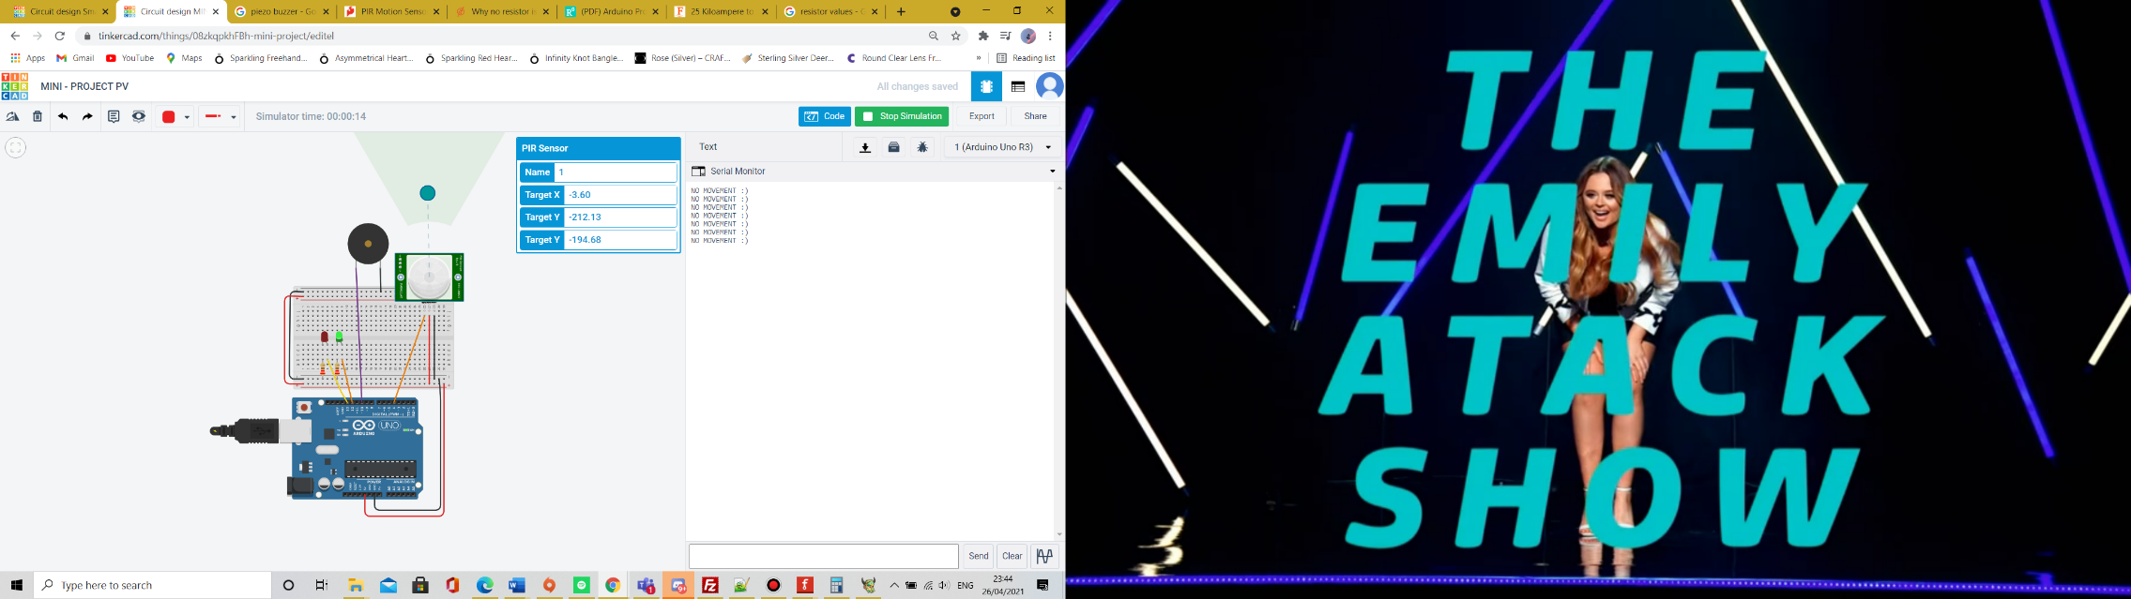

When there is no object in PIR sensor in the serial print it shows no movement :). And the green LED keeps blinking whiles red is completely off.

When PIR sensor detects an object InSite site it lights up automatically, the Piezo starts buzzing, and a Red led will start flashing and, on the serial, print it will print “Intruder alert :(”

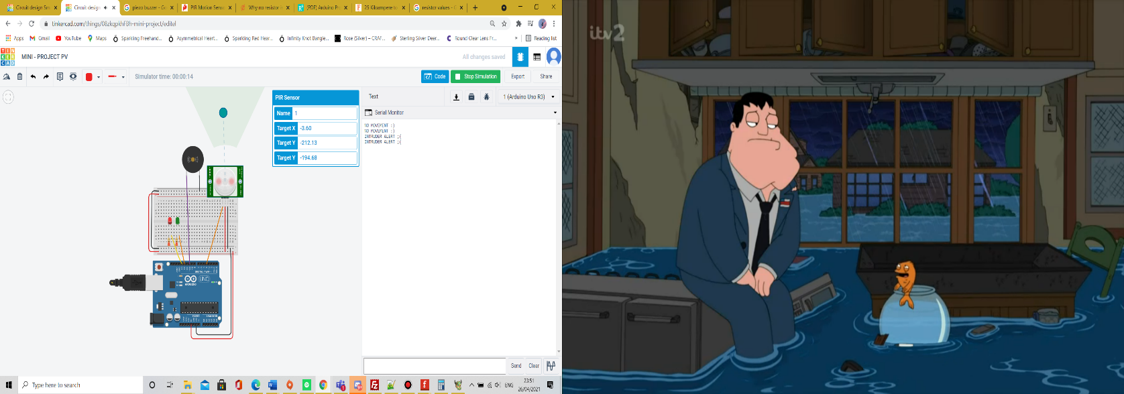

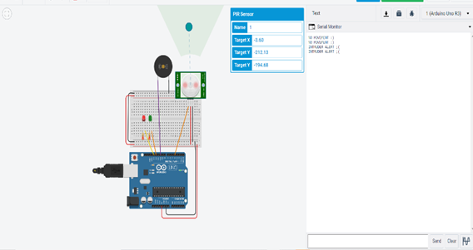

Conclusion:

In conclusion the circuit has shown a lot of success criteria. The result can be used as an IT security device. The work in general was challenging but fun to make. In future I can look to improve this project such as making reaction times of the LED and Piezo quicker which was seen as a weakness during testing. The project still has strengths such as performing the general functions and fully being able to do what I wanted it to do. In the real world I would be also looking at design techniques for the project such as maybe covering the circuit for it to avoid damage and where the circuit will be placed in an environment in real life. The coding had good structure and is easy to read also which is a good strength, after seeking reviews from peers also were also the same as project not having a quick enough reaction time and more detail for non-programmers to be able to understand the code properly with better annotations to read and follow in future, I will look to add better side notes with my code with a much more breakdown for people to understand it better. Another improvement after finishing the project I can add in future, would probably be in LCD, I didn’t add it because I thought it would make my work too chunky and because I’m already printing one result to Serial print meaning a computer will have to be on before viewing, in future I would consider an LCD and also a Bluetooth connection so that the user can be alerted If they are not near the area. For LED bulbs they were a good strength a simple but effective way for user to be indicated in future I can also improve this by using less bulb and use a RGB instead as it will take up less space. The piezo is a strength in the project as the annoying sound will definitely capture the attention of the user but can arguably seen as a weakness at the same time , modern society like to use alarms that are loud but also pleasant to the ear , I learned that piezo can output sound in different frequencies and can even be musical so in future I can change piezo sounds to sound in a pattern form loud but pleasant to the user . Overall, in future I would consider more user-friendly components since other people will be using such devices, in conclusion the project works okay but always there is room for improvement.

